**DAILY ONLINE ACTIVITIES SUMMARY**

|  |  |  |  |  |  |  |  |  |
| --- | --- | --- | --- | --- | --- | --- | --- | --- |
| **Date:** | **26-05-2020** | | | | | **Name:** | **Apeksha Rane** | |
| **Sem & Sec** | **A** | | | | | **USN:** | **4AL17CS010** | |
| **Online Test Summary** | | | | | | | | |
| **Subject** | | **COMPUTER GRAPHICS AND VISUALIZATION** | | | | | | |
| **Max. Marks** | | **30** | | **Score** | | | **21** | |
| **Certification Course Summary** | | | | | | | | |
| **Course** | **INTRODUCTION TO ETHICAL HACKING** | | | | | | | |
| **Certificate Provider** | | | Great learning  Academy | | **Duration** | | | 10hours |
| **Coding Challenges** | | | | | | | | |
| **Problem Statement:** 1. Python Program to Read a Number n And Print the Series "1+2+…..+n= "  2. Python Program to Count the Number of Digits in a Number.  3. Python Program to Check if a Number is a Palindrome.  4.  Python Program to Print all Integers that Aren’t Divisible by Either 2 or 3 and Lie between 1 and 50.  5. Given an array A of size N where the array elements contain values from 1 to N with duplicates, the task is to find total number of subarrays which start and end with the same element.  6. Write a program in C to print all permutations of a given string using pointers. | | | | | | | | |
| **Status: Done** | | | | | | | | |
| **Uploaded the report in Github** | | | | | **YES** | | | |
| **If yes Repository name** | | | | | <https://github.com/Apeksha12appu/19-5-2020-online-coding-activity> | | | |
| **Uploaded the report in slack** | | | | | **YES** | | | |

Online Test Details:

Subject:-Computer Graphics and Visualization

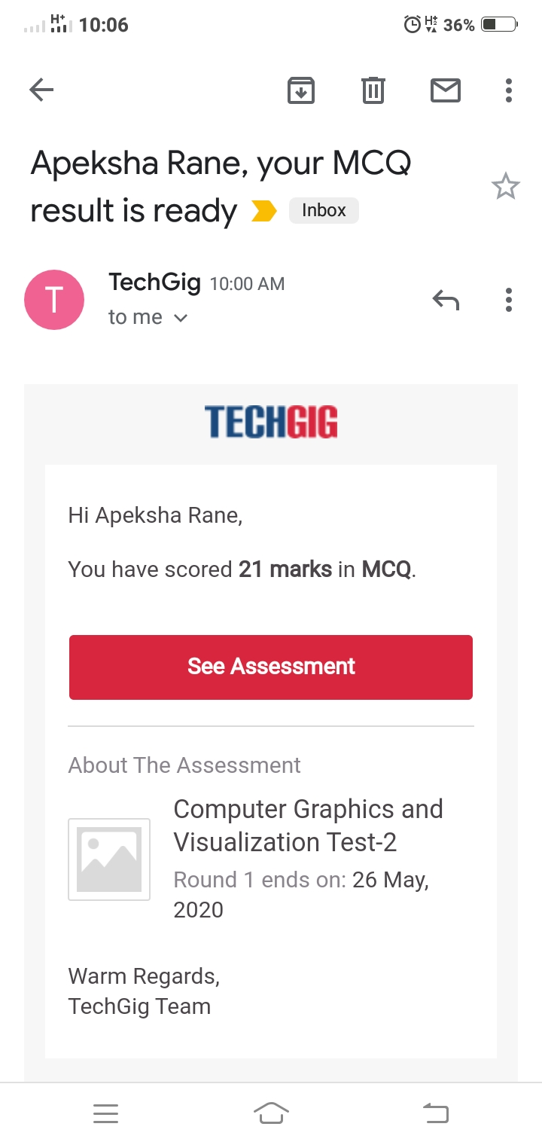

Certification Course Details:

**Introduction to Ethical Hacking:**

Today i have written quiz exam and got certificate:

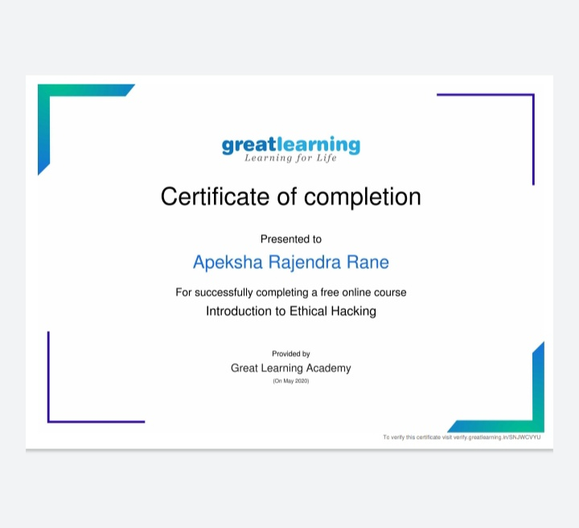

Coding Challenges Details:

1. 1. This is a Python Program to read a number n and print and compute the series “1+2+…+n=”.  
   Problem Description  
   The program takes a number n and prints and computes the series “1+2+…+n=”.

n = input("Enter Number ")

n = int (n)

sum = 0

for num in range(0, n+1, 1):

sum = sum+num

print("SUM of first ", n, "numbers is: ", sum )

**output:**

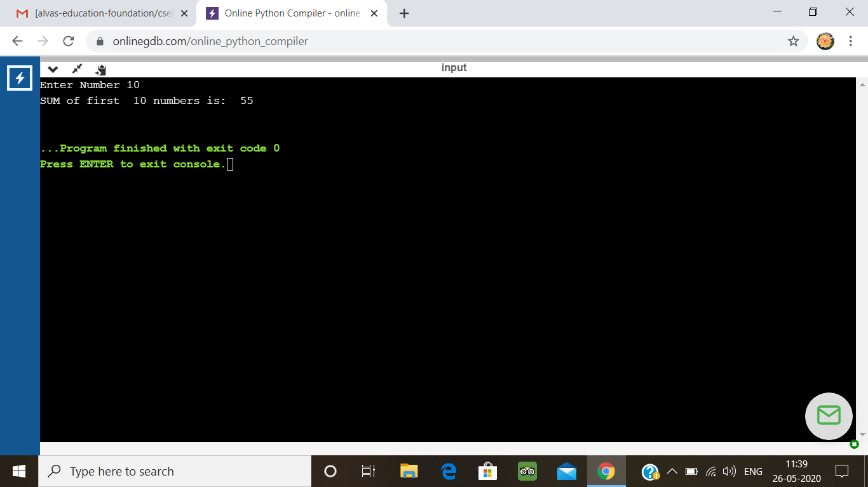

2. Python Program to Count the Number of Digits in a Number

n=int(input("Enter number:"))

count=0

while(n>0):

count=count+1

n=n//10

print("The number of digits in the number are:",count)

**output:**

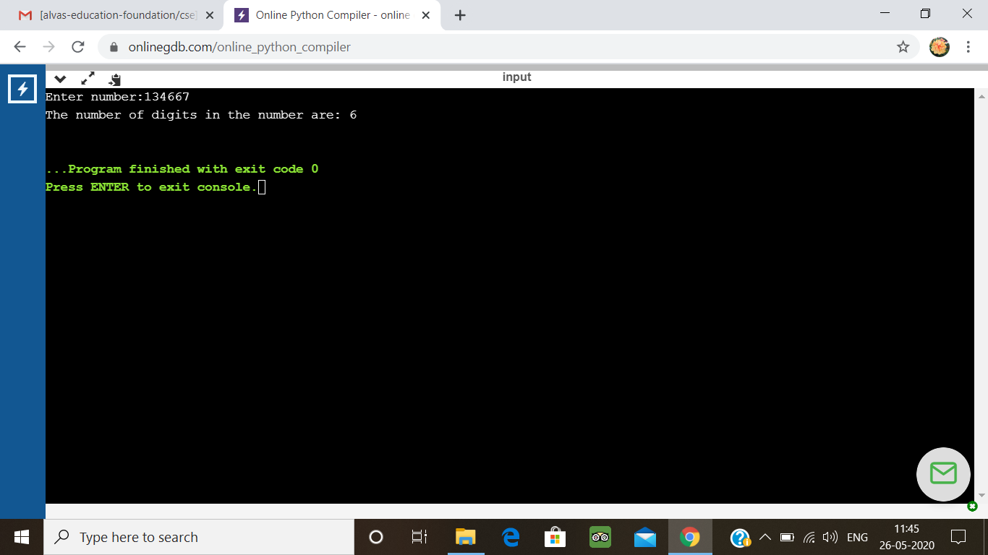

3. Python Program to Check if a Number is a Palindrome

n=int(input("Enter number:"))

temp=n

rev=0

while(n>0):

dig=n%10

rev=rev*10+dig

n=n//10

if(temp==rev):

print("The number is a palindrome!")

else:

print("The number isn't a palindrome!")

**output:**

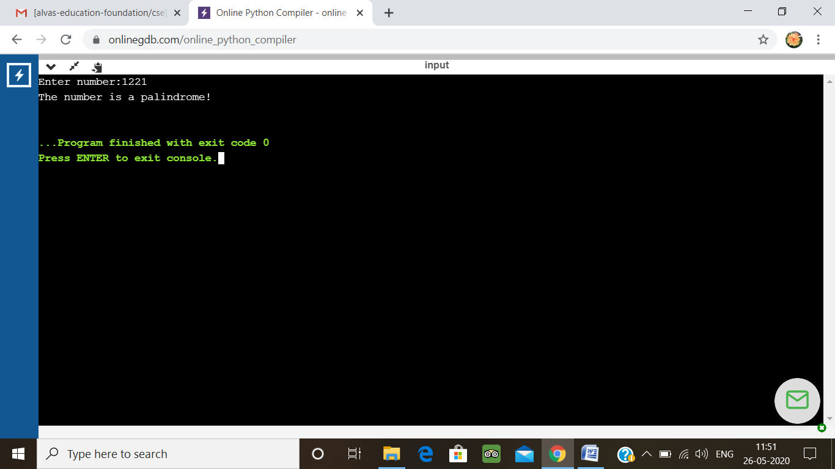

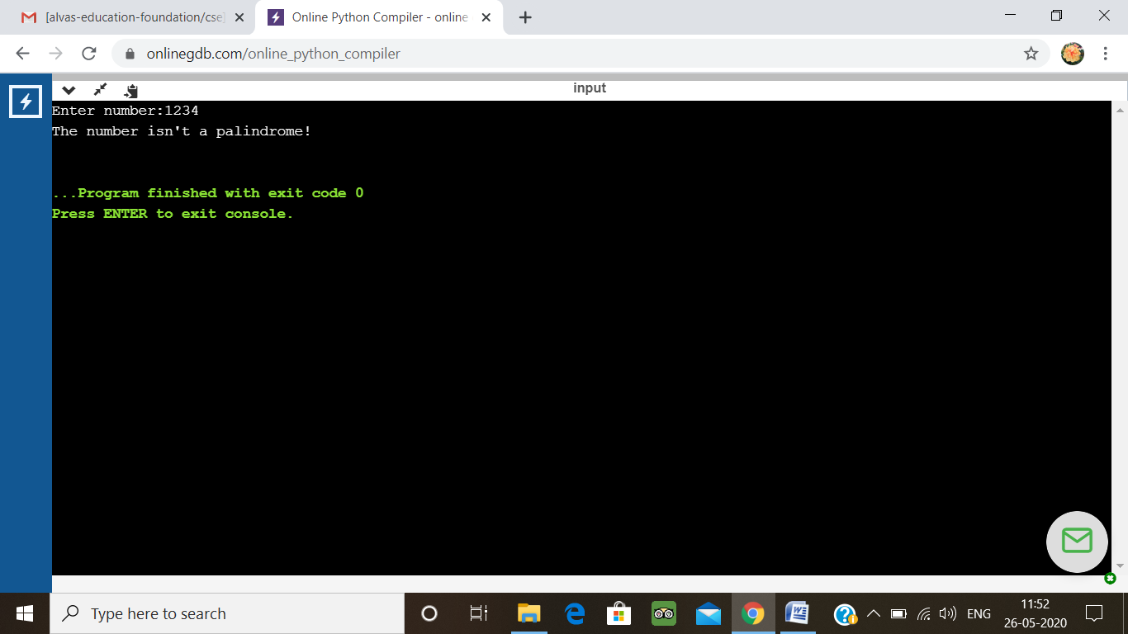

4. Python Program to Print all Integers that Aren’t Divisible by Either 2 or 3 and Lie between 1 and 50

for i in range(0, 51):

if((i%3!=0) & (i%5!=0)):

print(i)

**output:**

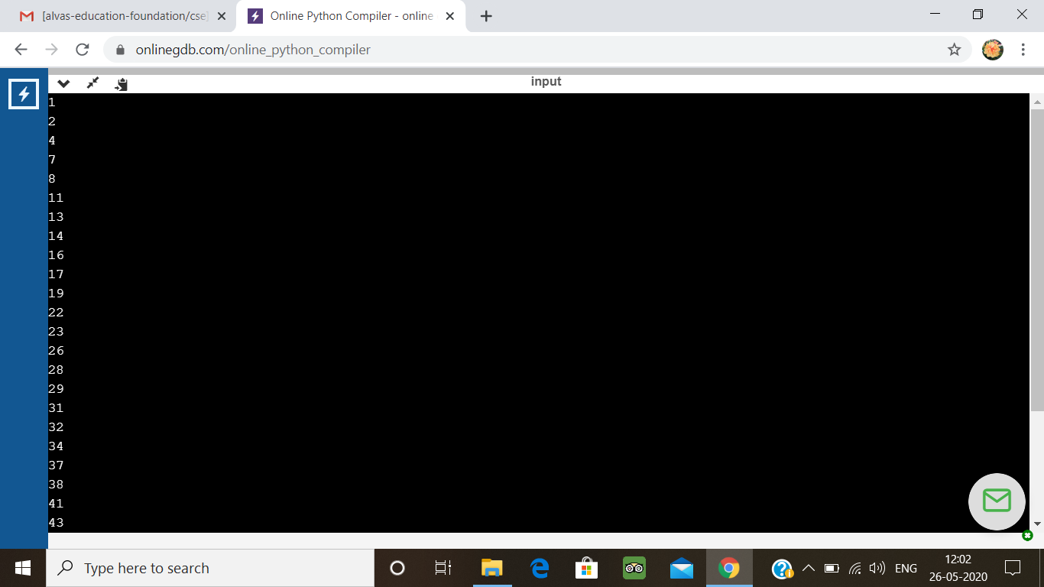

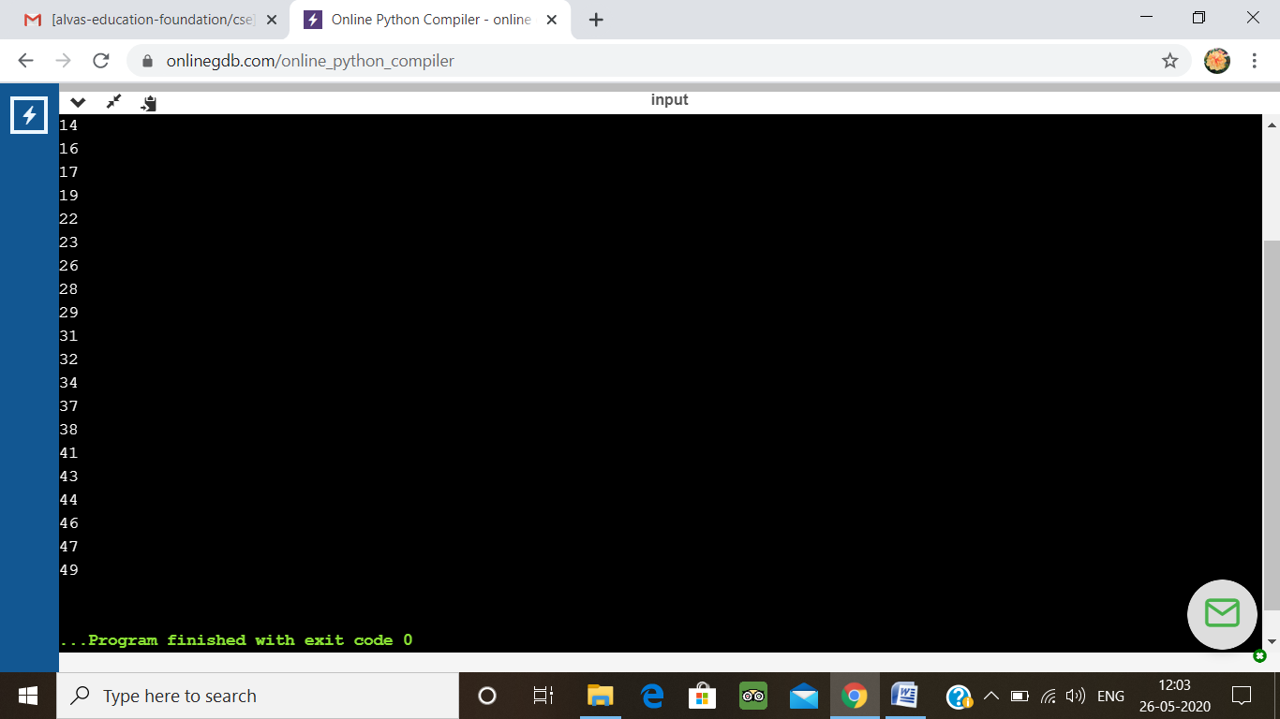

5.  Given an array A of size N where the array elements contain values from 1 to N with duplicates, the task is to find total number of subarrays which start and end with the same element

public class Main {

public static void cntArray(int A[], int N)

{

int result = 0;

for (int i = 0; i < N; i++) {

result++;

int current_value = A[i];

for (int j = i + 1; j < N; j++) {

if (A[j] == current_value) {

result++;

}

}

}

System.out.println(result);

}

public static void main(String[] args)

{

int[] A = { 1,2,1,5,2};

int N = A.length;

cntArray(A, N);

}

}

**Output:**

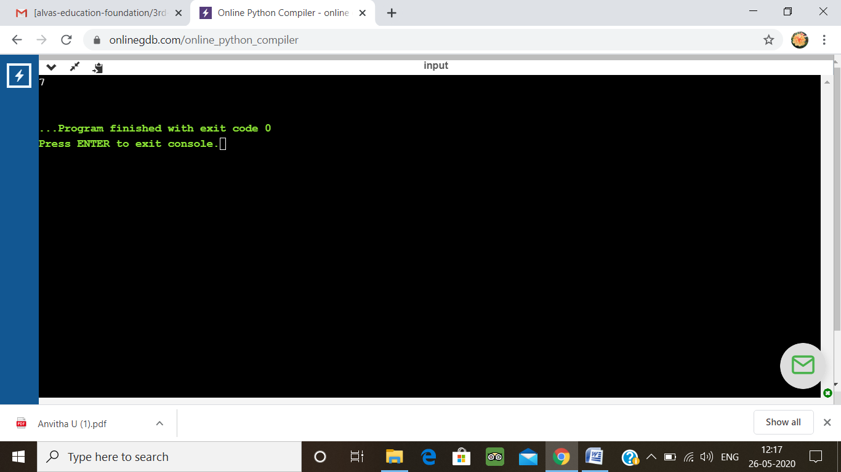

6. Write a program in C to print all permutations of a given string using pointers

#include <stdio.h>

#include <string.h>

void swap (char *x, char *y)

{

char temp;

temp = *x;

*x = *y;

*y = temp;

}

void permute(char *a, int i, int n)

{

int j;

if (i == n)

printf("%s\n", a);

else {

for (j = i; j <= n; j++)

{

swap((a + i), (a + j));

permute(a, i + 1, n);

swap((a + i), (a + j));

}

}

}

int main()

{

char a[20];

int n;

printf("Enter a string: ");

scanf("%s", a);

n = strlen(a);

printf("Permutaions:\n");

permute(a, 0, n - 1);

getchar();

return 0;

}

**Output:**

